

Proposal
for
1:1 XTD-400K TWTA System
with Load switch

Prepared for

11/18/2020
Revision A

3550 Bassett Street
Santa Clara, CA 95054

Sales POC: |  | Technical POC: | Doug Morison
Title: |  | Title: | Snr Sales Applications Engineer
Phone (office): |  | Phone (office): | (703) 257-2092
Phone (cell): |  | Phone (cell): | (408) 642-8489
Email: |  | Email: | doug.morison@xicomtech.com
Introduction

Comtech Xicom Technology (CTXI) is pleased to provide this technical proposal for a 1:1 XTD-400K Traveling Wave Tube Amplifier (TWTA) System with load switch.

The amplifier offered is a Ku-band antenna mounted TWTA, model XTD-400K. Monitor and control of the amplifiers and system will be via the XTCT-124D controller with color touch screen interface. Remote control is possible via Ethernet or serial interfaces.

System Description

The system block diagram is shown in Figure 1.

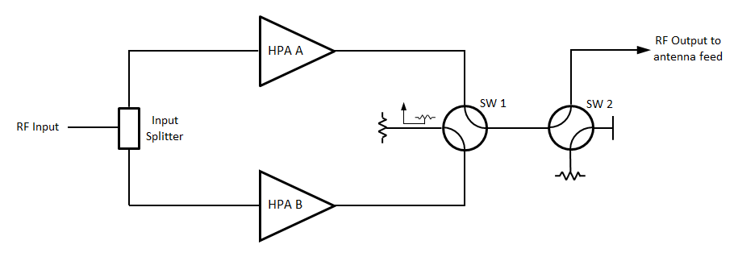
Figure 1 – System block diagram

Redundancy control for the 1:1 system with load switch is managed by the TWTA integrated redundancy control. Monitor and control of the 1:1 system and TWTAs is via a XTCT-124D remote controller. The system screen on the remote controller front panel provides monitor and control of the redundancy system. The other screens provide monitor and control of the individual TWTAs, including access to logging records for events and performance parameters, and setup menus for configuring the TWTAs and the system.

The HPA system output power is calculated as follows:

Flange Power of XTD-400K 55.44 dBm (350W)
Loss of 1:1 System with Load Switch at Ku-band 0.40 dB
Flange Power of HPA System 55.04 dBm (319W)

For 1:1 redundancy, the TWTAs each monitor the switches and the summary fault status of the other TWTA via a “X” cable. These signals are contact closures for maximum reliability. If the off-line TWTA detects that the on-line TWTA has failed, it switches the output switch.

The XTCT-124D remote controller communicates with the TWTAs via Ethernet cables. This greatly improves the speed of communications and simplifies the installation. There is no need for custom made and expensive M&C cables; Ethernet cables can be run and terminated at installation.

The 1:1 XTD-400K system outline is shown in Figure 2.
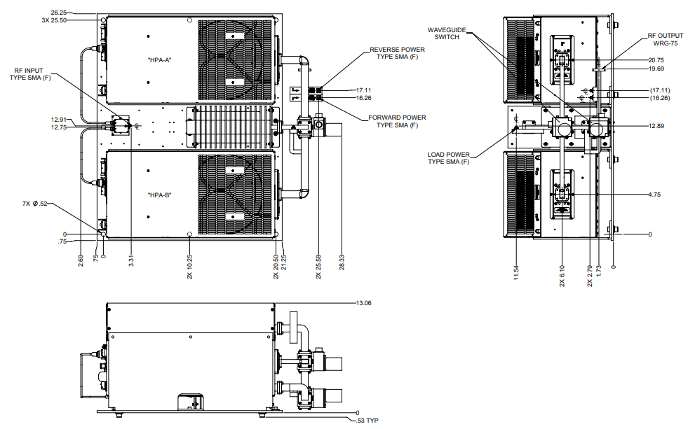

Figure 2 – 1:1 XTD-400K System outline

M&C cabling between the antenna mounted system and the remote controller requires only Ethernet cables. This simplifies system installation with no custom M&C cables being required. An Ethernet switch is required, and this is often CFE. Alternatively, customer can utilize an integrated 5 port Ethernet switch in the XTCT-124D controller.

Amplifier Description

The amplifiers offered are the model XTD-400K Traveling Wave Tube Amplifiers (TWTAs). These digital, high efficiency antenna mount amplifiers are designed for fixed and mobile uplink applications, and incorporate CXTI’s latest technology advancements, RF gain control, a solid-state pre-amplifier / linearizer, RF filters, cooling, and monitor & control (M&C) systems. The B1 version includes the option of integrated BUC. An internal 10MHz reference is also included removing the need for an external reference.

The TWTA uses a CW rated TWT. The rated power (saturated) of the TWTA at the output flange is 350W. The high frequency resonant conversion power supply is highly efficient and allows for quick recovery from prime power outages.

The XTD-400K amplifier is shown in Figure 3.

Figure 3 – XTD-400K Amplifier

Technical data on the XTD-400K amplifier is available via the following link:

https://xicomtech.com/Portals/0/Documents/Products/TWTA%20-%20Antenna/XTD-400C-X-K%20Rev%209.pdf?ver=2018-12-13-155741-337

XTCT Remote Controller

Monitor and control of the antenna mounted system will be with the CXTI remote controller, XTCT-124D. The remote controller is 3RU high and is shown in Figure 4. It uses a color touch screen interface the same as for the CXTI rack mounted amplifier products.

Figure 4 – XTCT-124D Controller

Product information on the XTCT-124D remote controller is provided in the accompanying XTCT Remote Controller data sheet.

All Information on the touch screen displays is color coded for easy interpretation and the control operation is intuitive. Touch the parameter to be changed and it will be highlighted in yellow with an indication that adjustment via the adjust knob is now possible. This two-handed approach to adjustments and other security features ensure that unwanted changes are not made.

The color touch screen user interface provides monitor and control of the individual amplifiers and the 1:1 redundancy system with load switch. 5 main screens are used to monitor, control and configure each amplifier and system. These are:
- System screen,
- Amplifier screen,
- Events screen,
- Trends screen, and
- Setup screen

Critical status and performance information is displayed at all times at the top of each screen display. In this top section of the display, the user can select which amplifier details and controls are displayed and accessible. The system screen will be the same for all amplifiers but the selected amplifier will be highlighted. The system screen for the 1:1 system with load switch is shown in Figure 5.

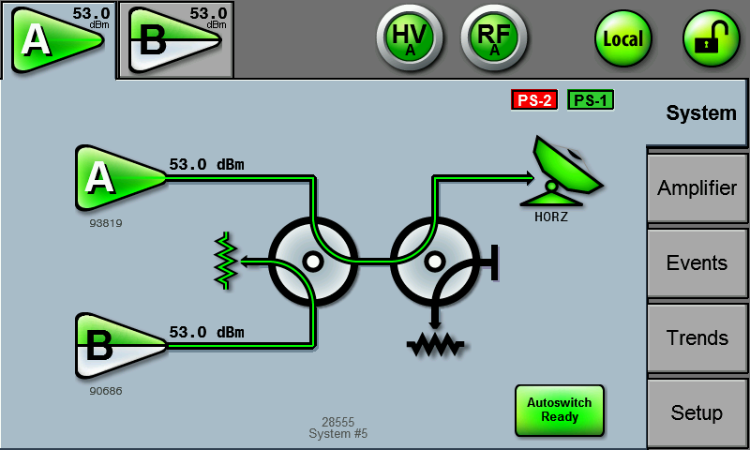

Figure 5 – 1:1 with Load Switch System Screen

On the System screen, the active RF path is shown highlighted in green.

All TWTA operating settings and parameters are displayed on the Amplifier screen. The Amplifier screen is shown in Figure 6.

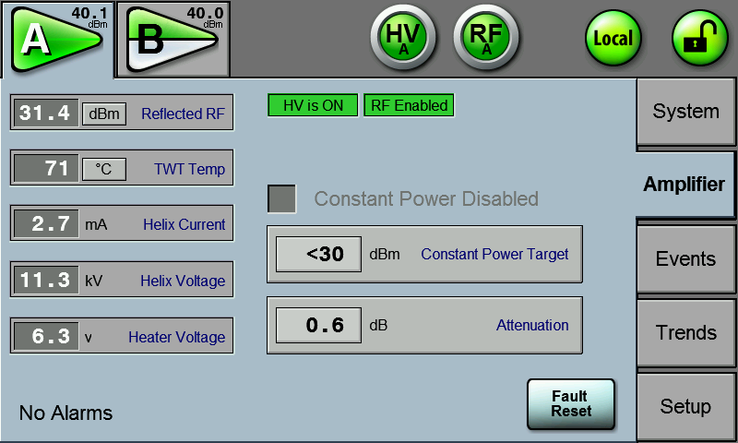

Figure 6 – Amplifier Screen

The XTCT remote controller records all event data and TWTA performance data and this data is available on the front screen. Changes in performance over long or short time periods can be reviewed with ease. The Events and Trends screens are shown in Figures 7 and 8 respectively.

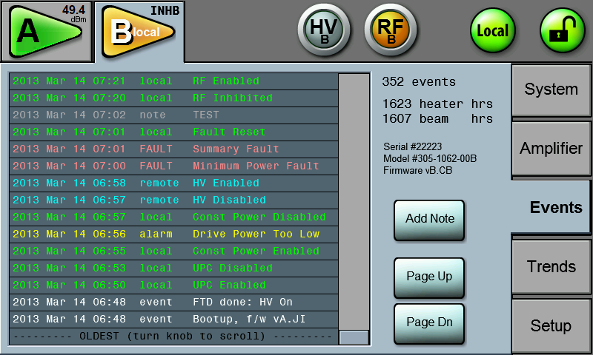

Figure 7 – Events Screen

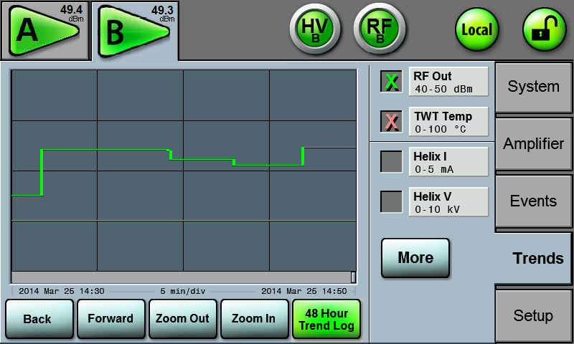

Figure 8 – Trends Screen

The final Set-up screen is used to configure the amplifier, including defining the system the amplifier is to be operating. This screen is also used to set alarm and fault levels, serial interface configuration, Ethernet interface settings and other amplifier interface options. The Setup screen is shown in Figure 9.

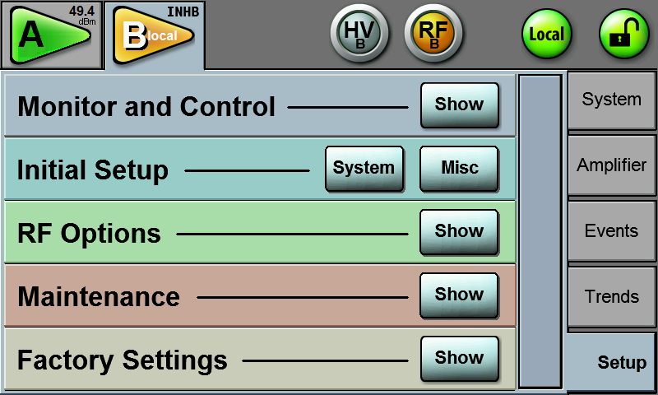

Figure 9 – Setup Screen

Remote Monitor and Control Description

The Ethernet interface is recommended for the remote monitor and control of the amplifiers and the 1:1 redundancy system.

The XTCT-124D remote controller provides web browser support via the Ethernet interface. The latest versions of web browsers such as Firefox, Goggle Chrome and Internet Explorer 11 are supported. This monitor and control approach provides near identical screen display and control to that provided on the front panel of the remote controller. A remote Amplifier screen example is shown in Figure 10. Download of the event data and trends data can be accomplished directly with the TWTAs.

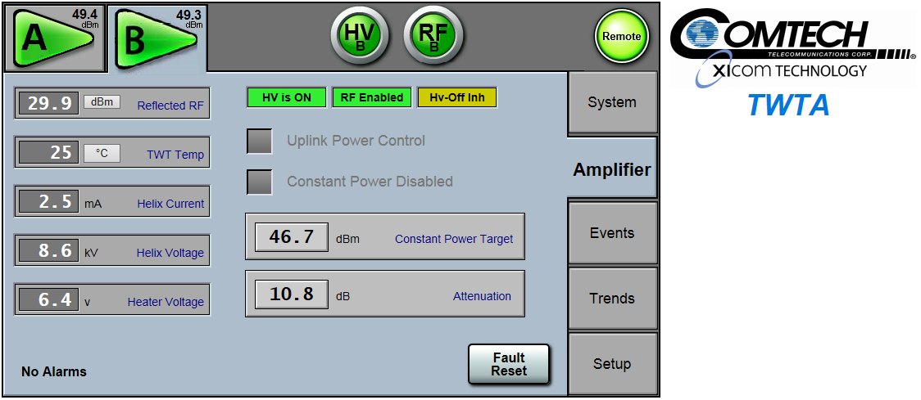

Figure 10 – Remote Amplifier Screen via Web Browser

Other Options

Other options are available which may be of interest when designing a new uplink facility.

Uplink Power Control

The CXTI rack mounted remote controller, XTCT-124D, has the option for uplink power control. This option eliminates the need for a separate UPC controller.

The output from a beacon receiver is applied to the UPC input of the remote controller. The remote controller monitors the beacon receiver signal and correspondingly adjusts the gain of the antenna mounted TWTAs in the system. This system interconnect is shown in Figure 11. With the UPC parameters configured, the TWTA attenuators are now used to automatically adjust the transmit output to compensate for uplink rain fade conditions.
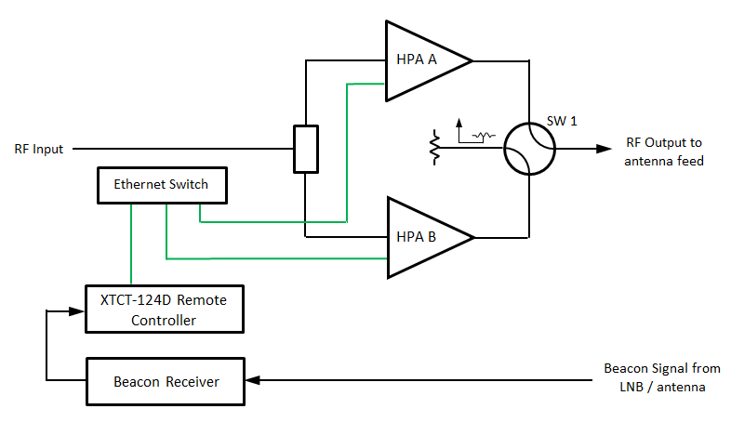

Figure 11 – UPC Interconnect

Set up of the UPC parameter is accomplished via the relevant section in the Setup screen. This is shown in Figure 12. Operating levels of the UPC can be found on the Amplifier screen but beacon receiver level is always shown in the dashboard section at the top of every screen.

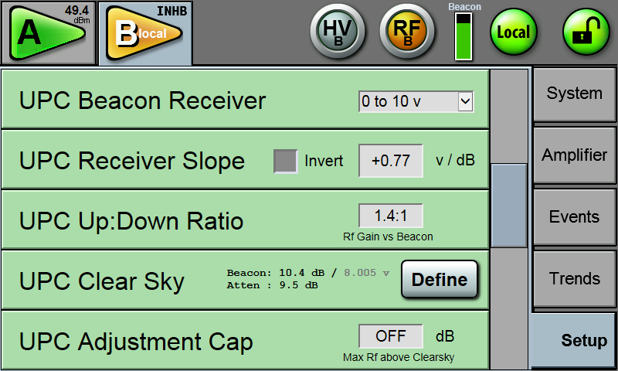

Figure 12 –Setup Screen (UPC)

